LCD chromebook removal When removing a LCD on a chromebook you want to make sure that you are really careful when doing so and always make sure that you are always have the right tools and know what you are doing. If you do not follow the proper procedures then you can potentially ruin your chromebook. Before you start however make sure you put on an esd wrist strap before proceeding Step 1- The first step you want to do is turn off your laptop and close your lcd screen. You must turn off your laptop or else you will could potentially ruin your device Step 2- Flip the screen over and take the screws off of the back panel. Step 3- After you want to carefully lift the back panel up and remove it. Step 4- Now after remove the back cover you will be visible to the the internal parts of the system. What you want to do is remove the wireless cables and the edp 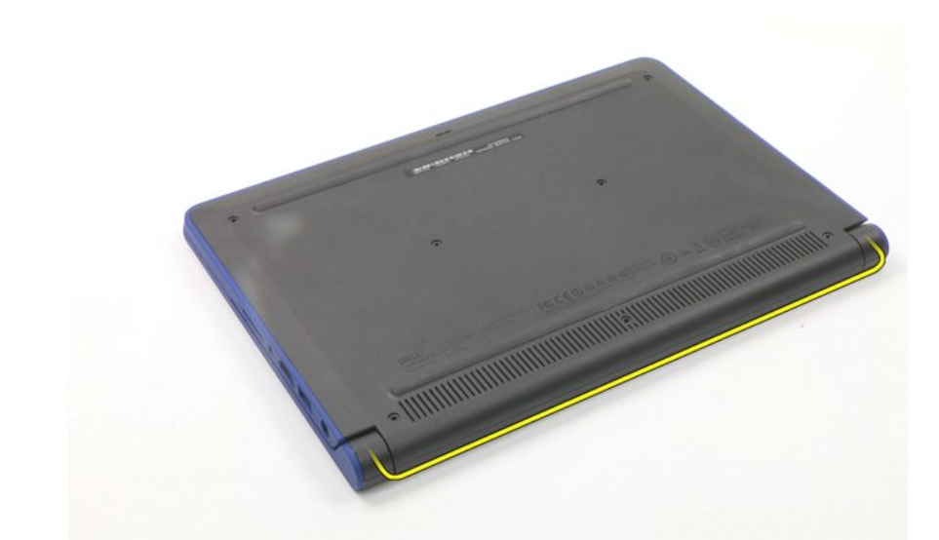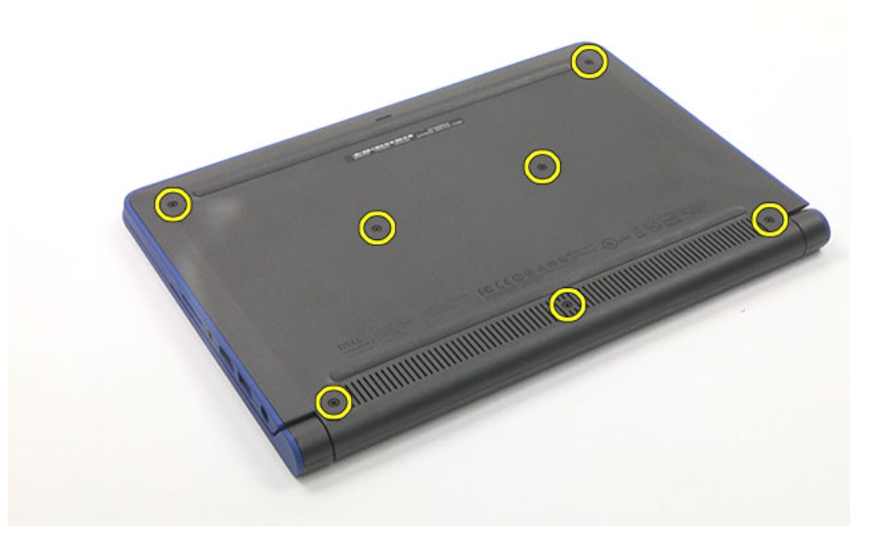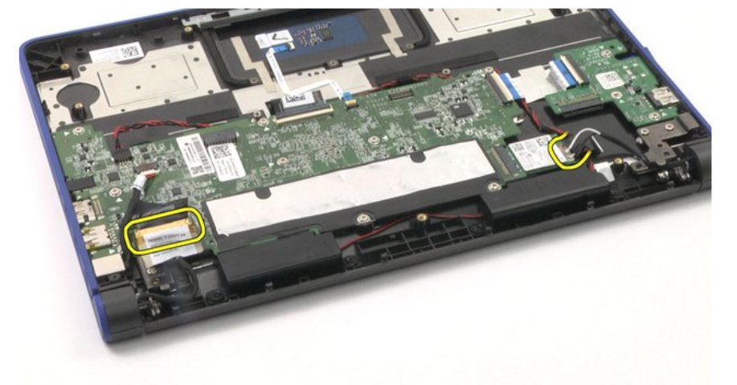

Step 5- After that you will want to remove the screws close by the wifi and edp card Step 6- Now what you want to do is carefully lift the two hinges so that you can carefully remove the display. Step7- After that you want to carefully lift up the hinges and remove it Step 8- After that you will take the new display for your laptop and place the lcd display back into the original location on the palm rest and reconnect all the cables. Make sure you always keep connect all the cables into the display not connecting all the cables to the display will obviously prevent the lcd from turning on or it might turn on and it will start flickering because of the loose cables so make sure that when you are reconnecting all the cables so that they are nice and tight 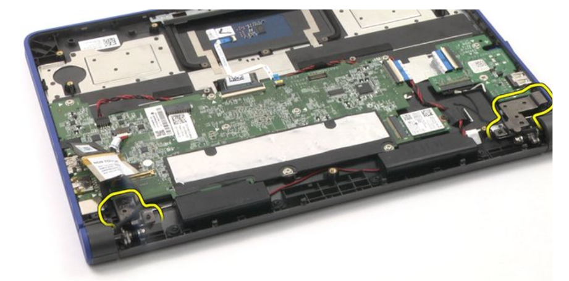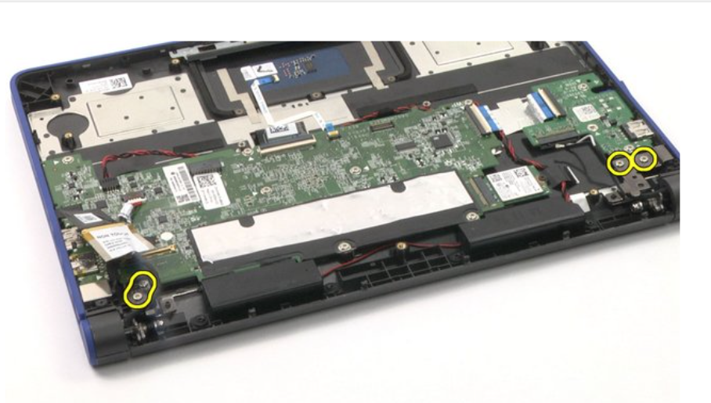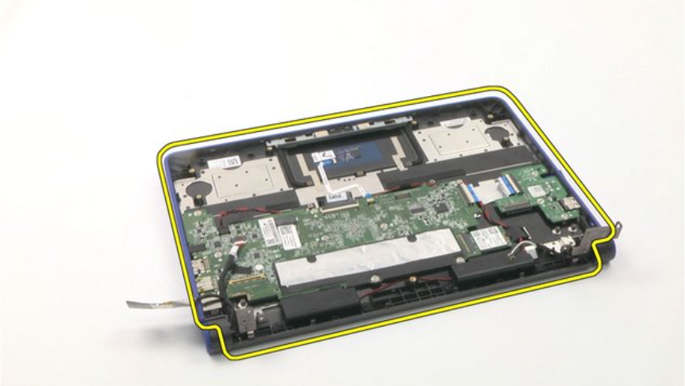

Step 9 - After you fully finished replacing your lcd you must verify if your lcd is actually working. So what you want to do is reconnect the system to a outlet and turn on the laptop and just let it boot. If the display is having problems turning on then it is because you didn't tighten the display cables. To test it out wiggle the display back and forth and if the display does not flicker then you are good.